**ETHNUS AWS WEBINAR**

**NAME: ABINESH K**

**Screenshots**

**Screenshots needed for Dashboards**

**1)AWS Login screen with Username**

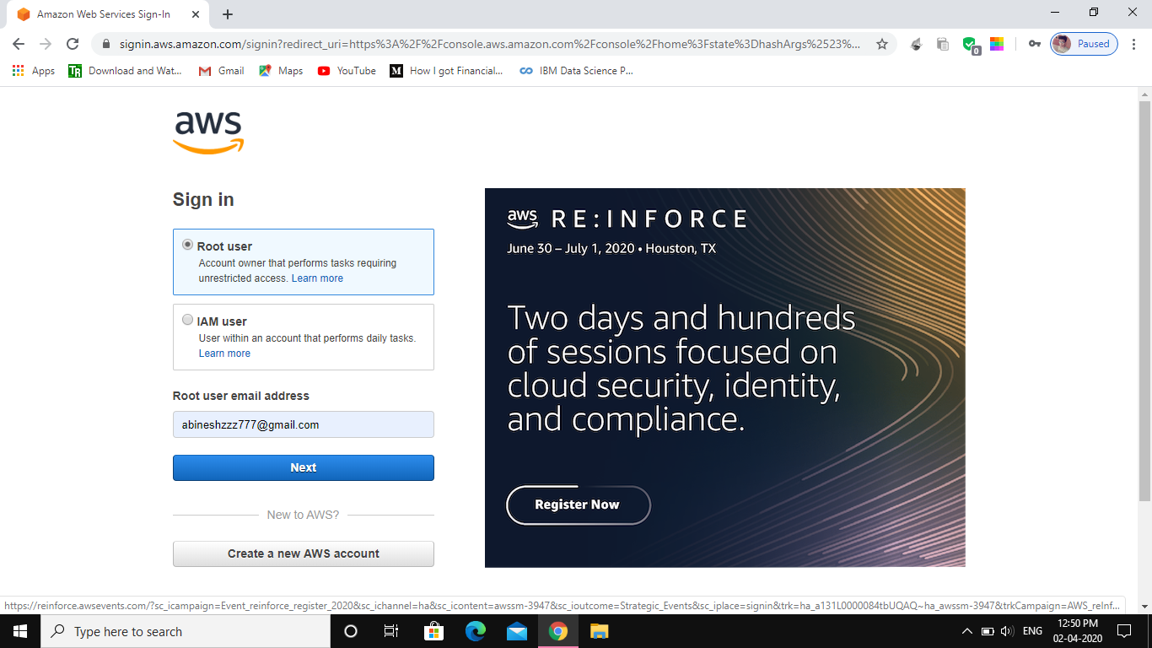

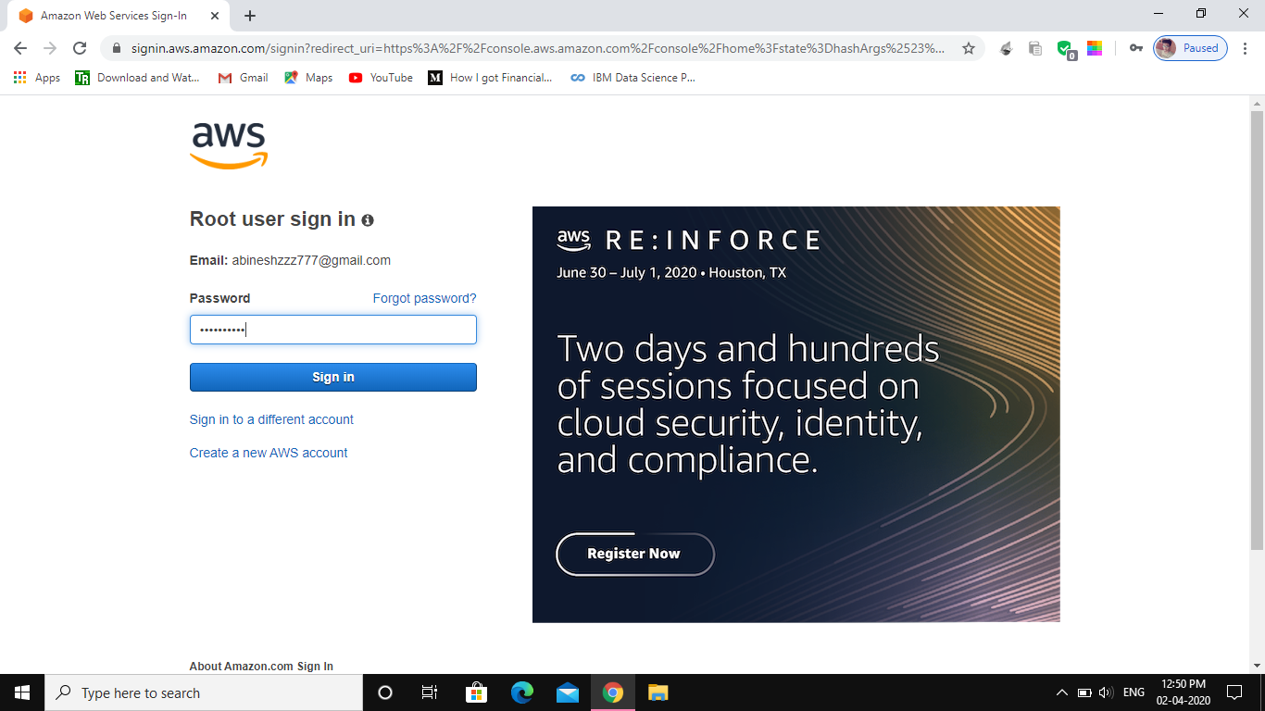

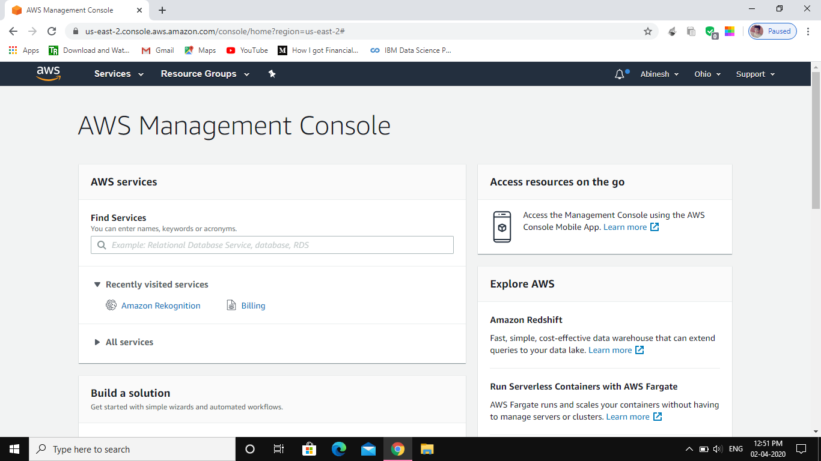

**2)EC2 Dashboard**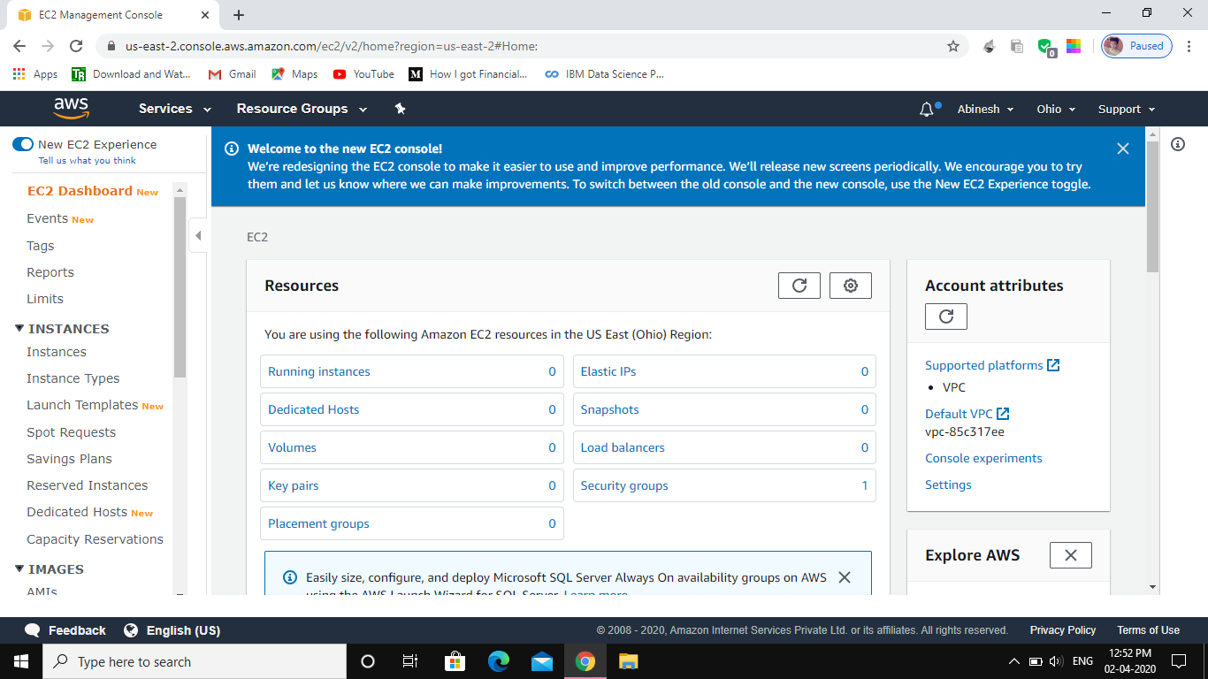

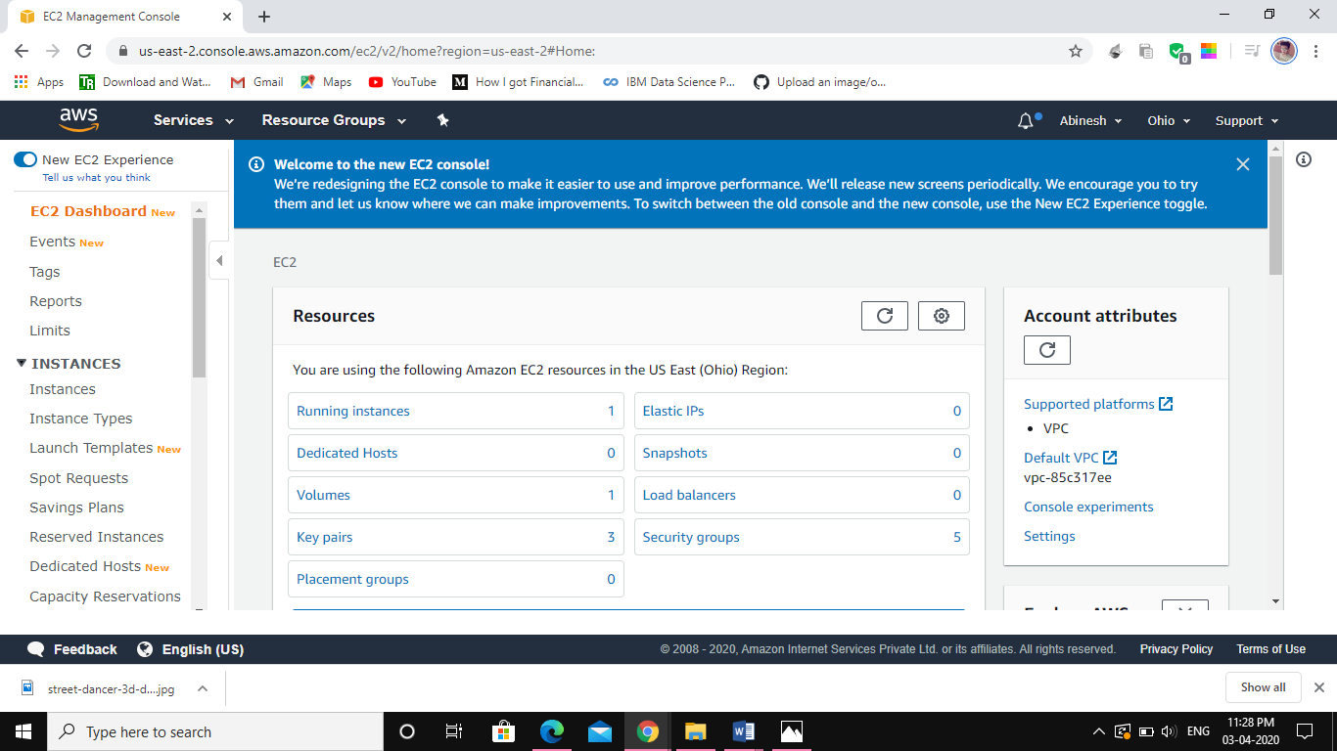

**3)S3 DASHBOARD:**

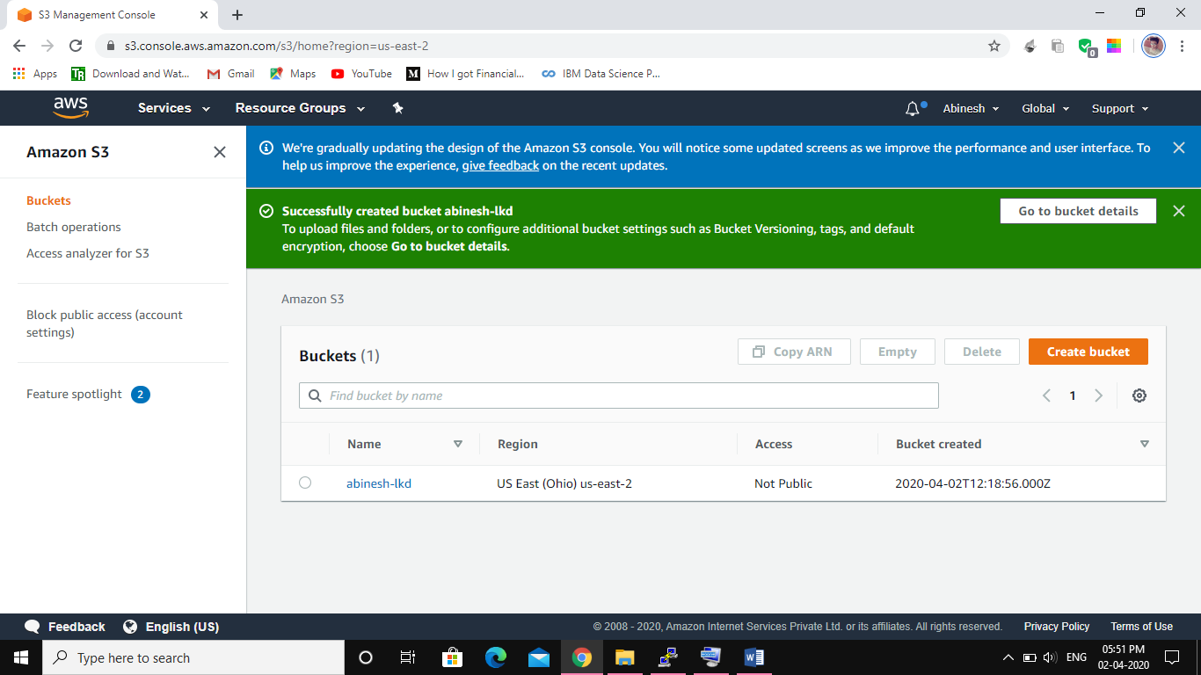

**4)Rekognition Dashboard**

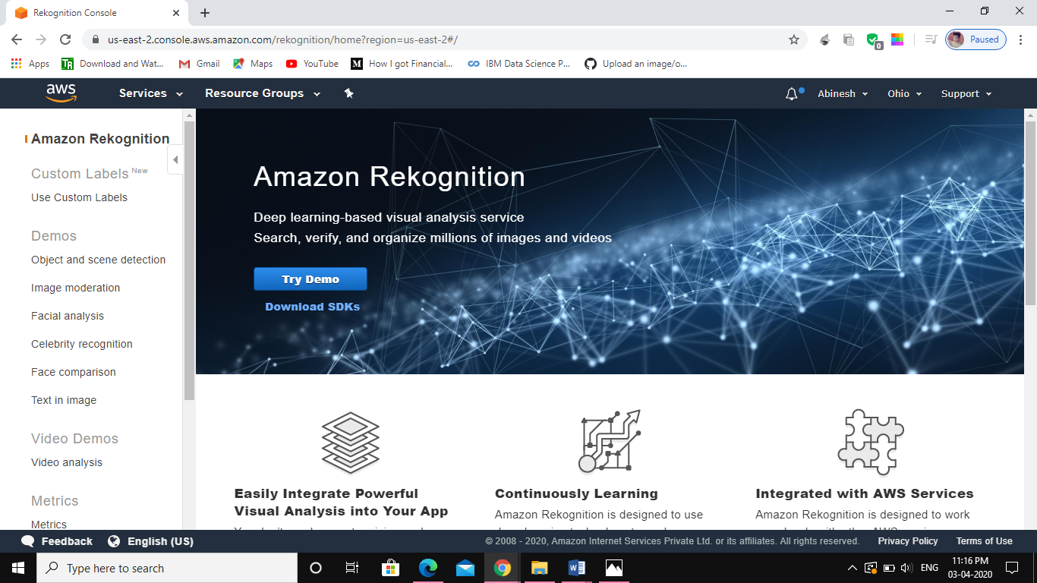

**Screenshots needed for EC2**

**1)Choosing an AMI**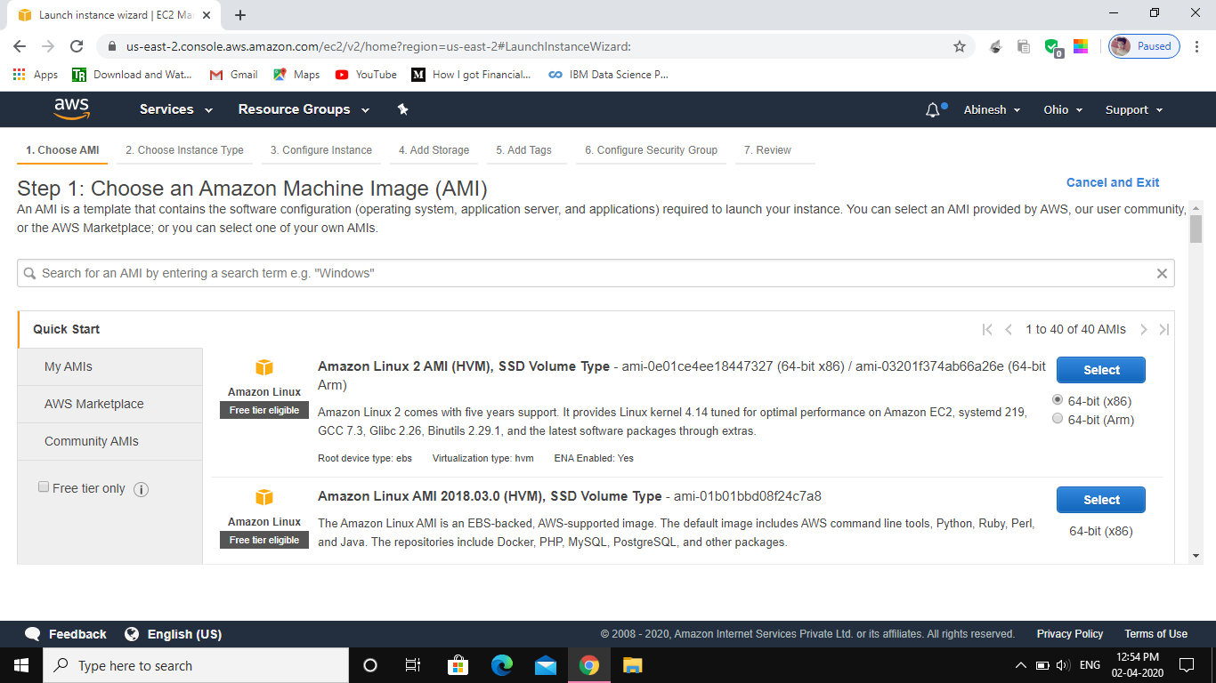

**2)Choosing an Instance Type**

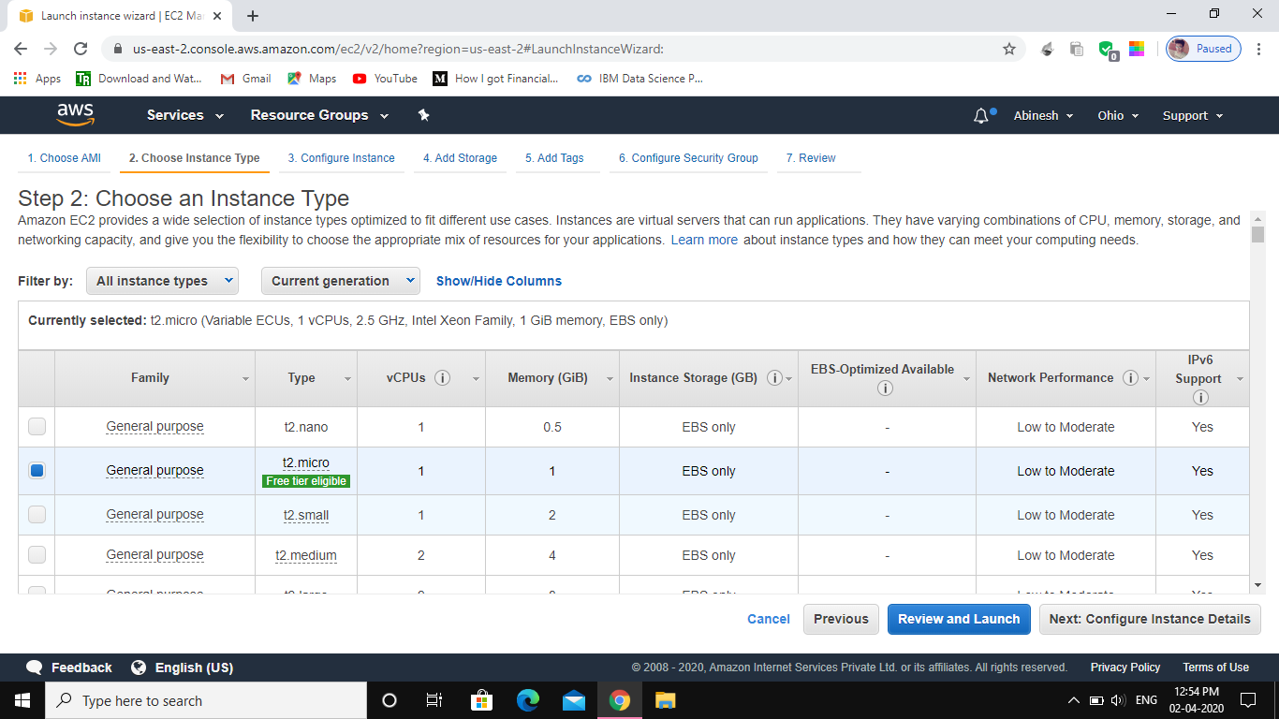

**3)Adding Storage**

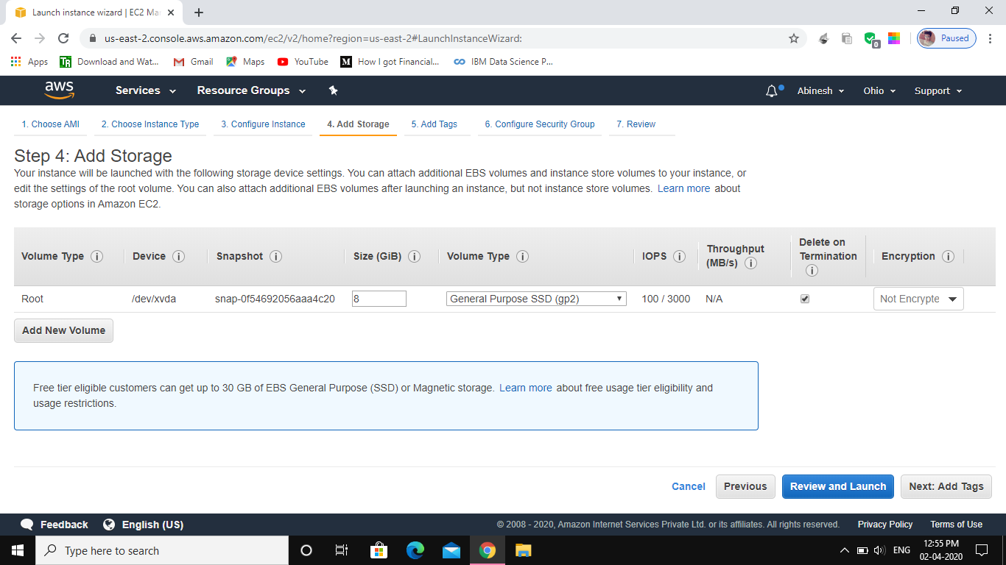

**4)CONFIGURING SECURITY GROUP: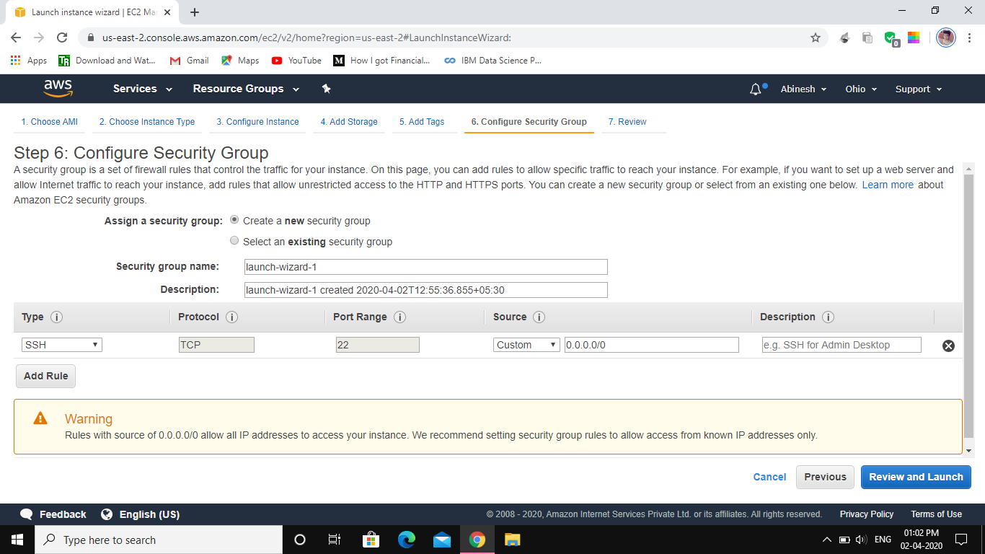5)KEY PAIR DOWNLOAD: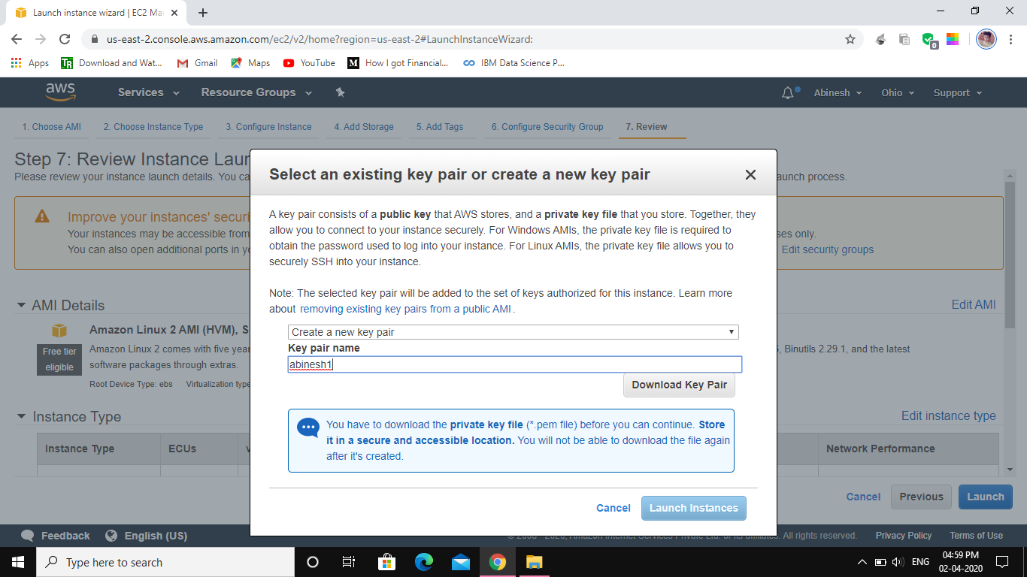6)** **PuTTYgen conversion from pem to ppk**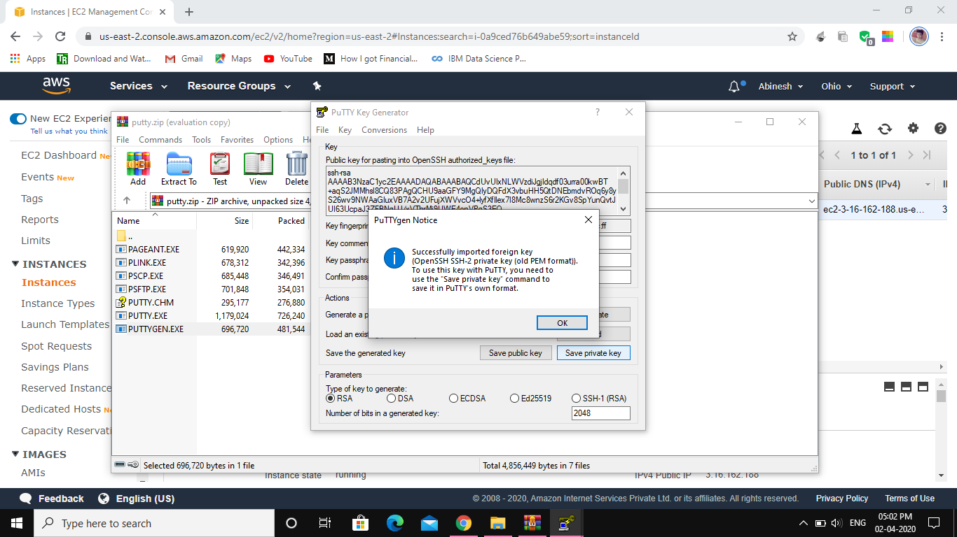

**7)Logged in EC2 black screen**

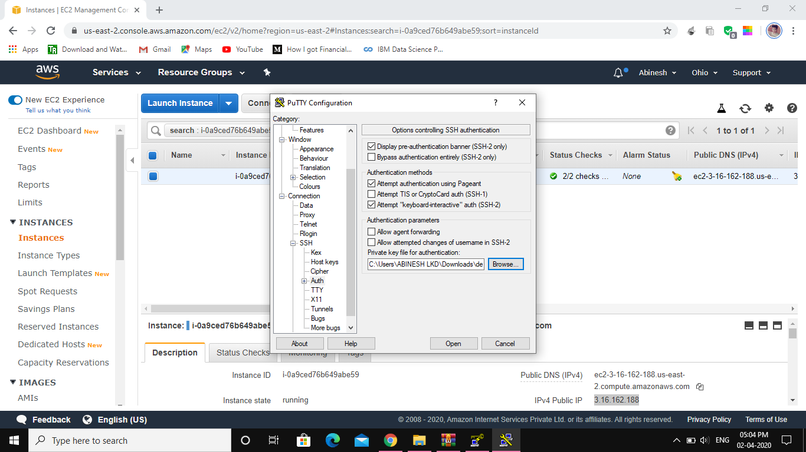

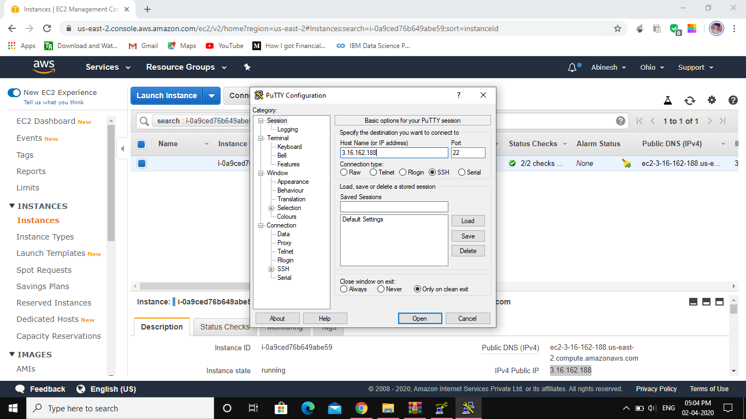

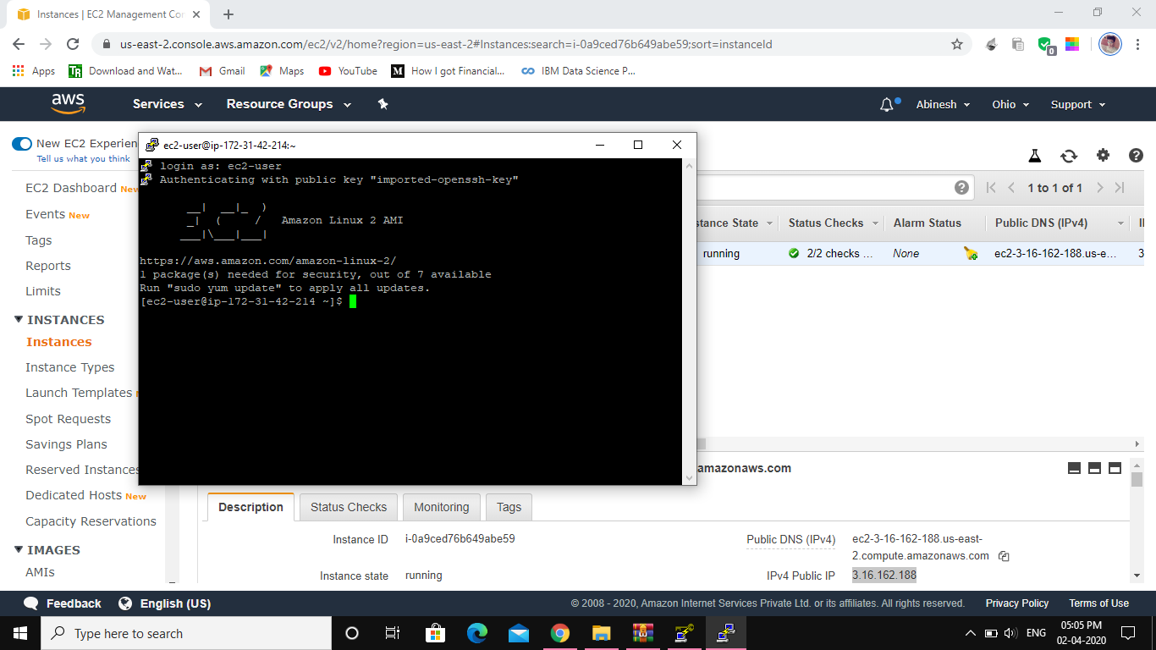

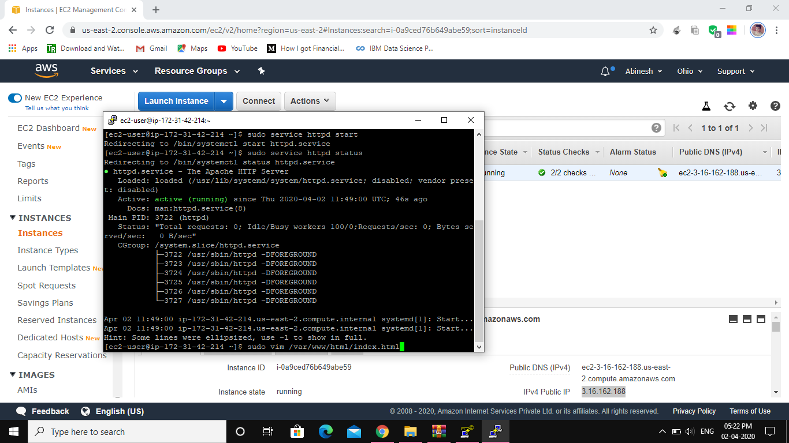

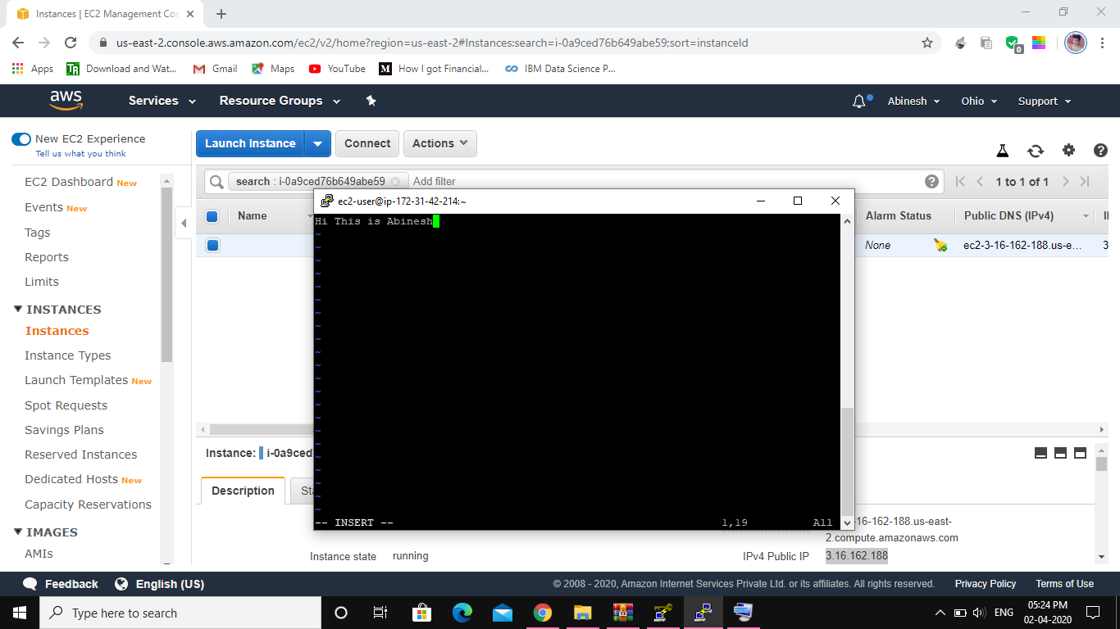

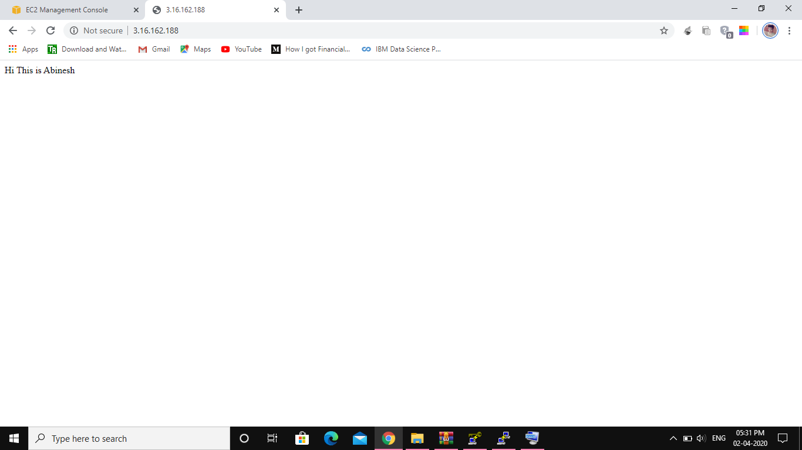

**Screenshots needed for S3**

1. **Creating a bucket**



1. **Uploading an Object**

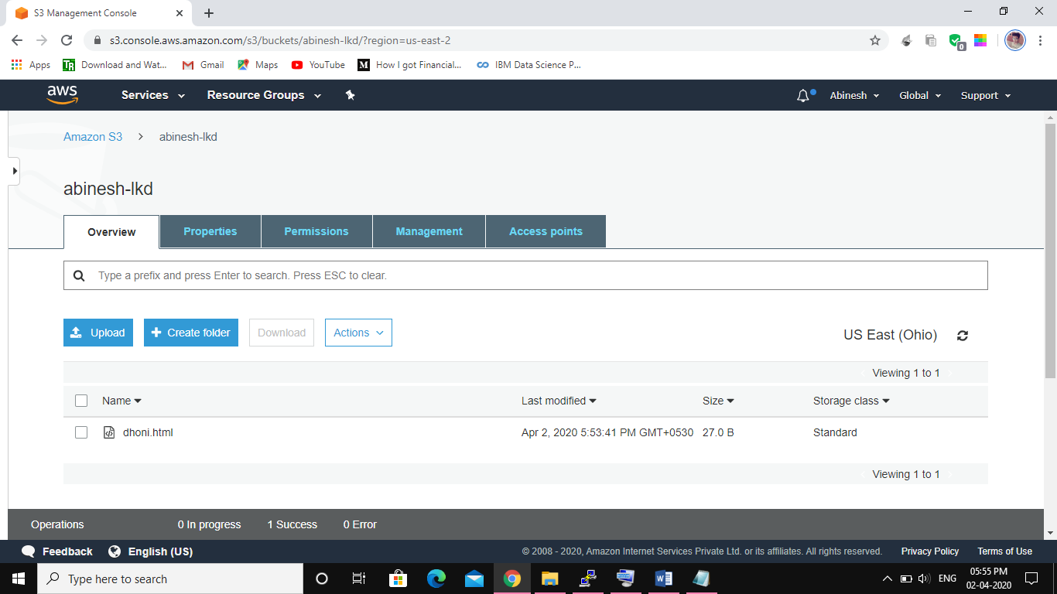

1. **Enabling Static Website**

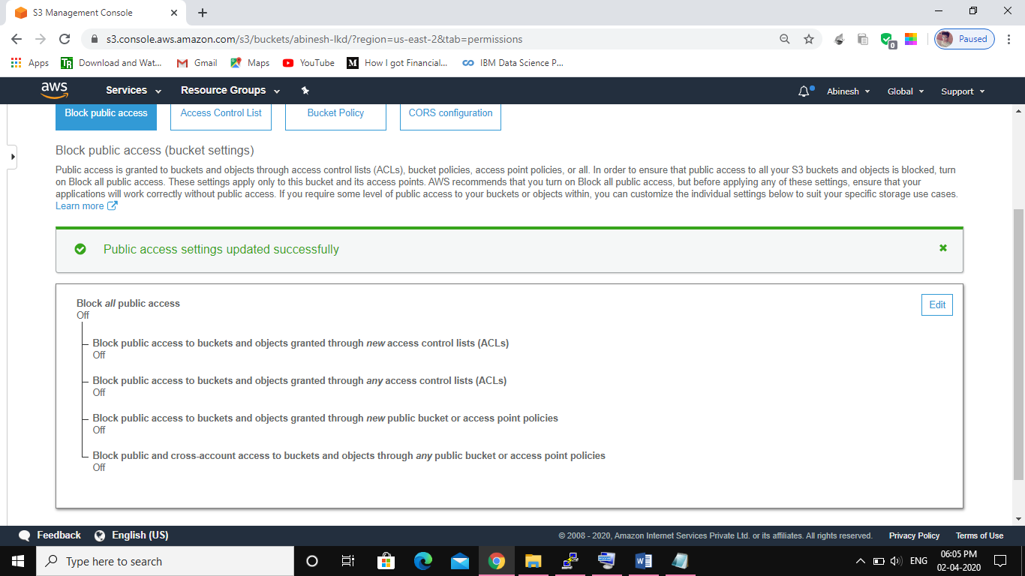

1. **Making the Object Public**

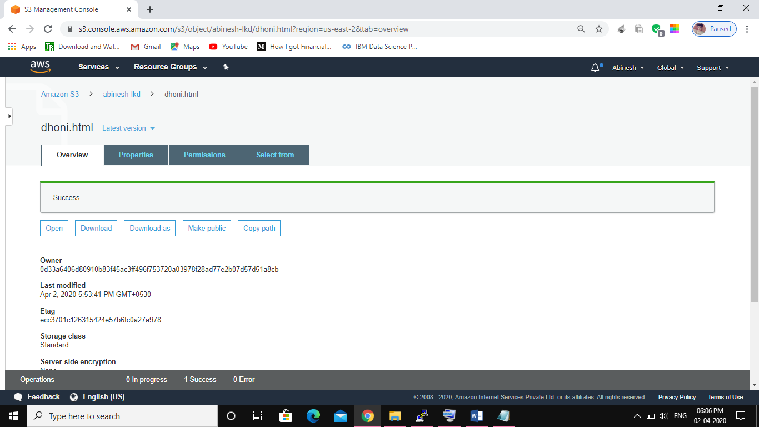

**5)Checking the S3 link on the browser**

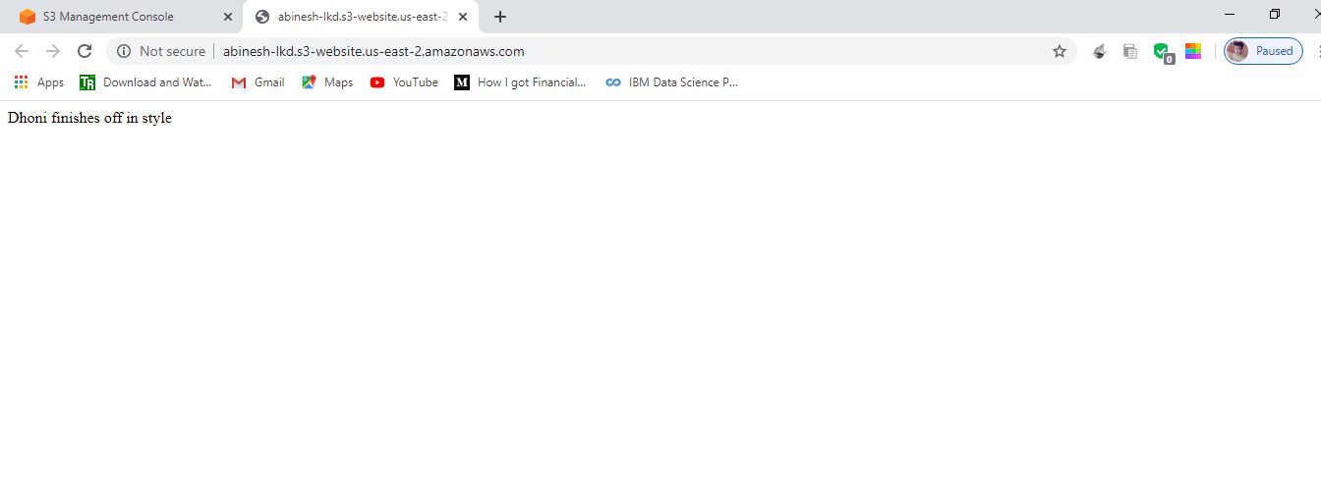

**Screenshots needed for Rekognition**

**1)Face Detect**

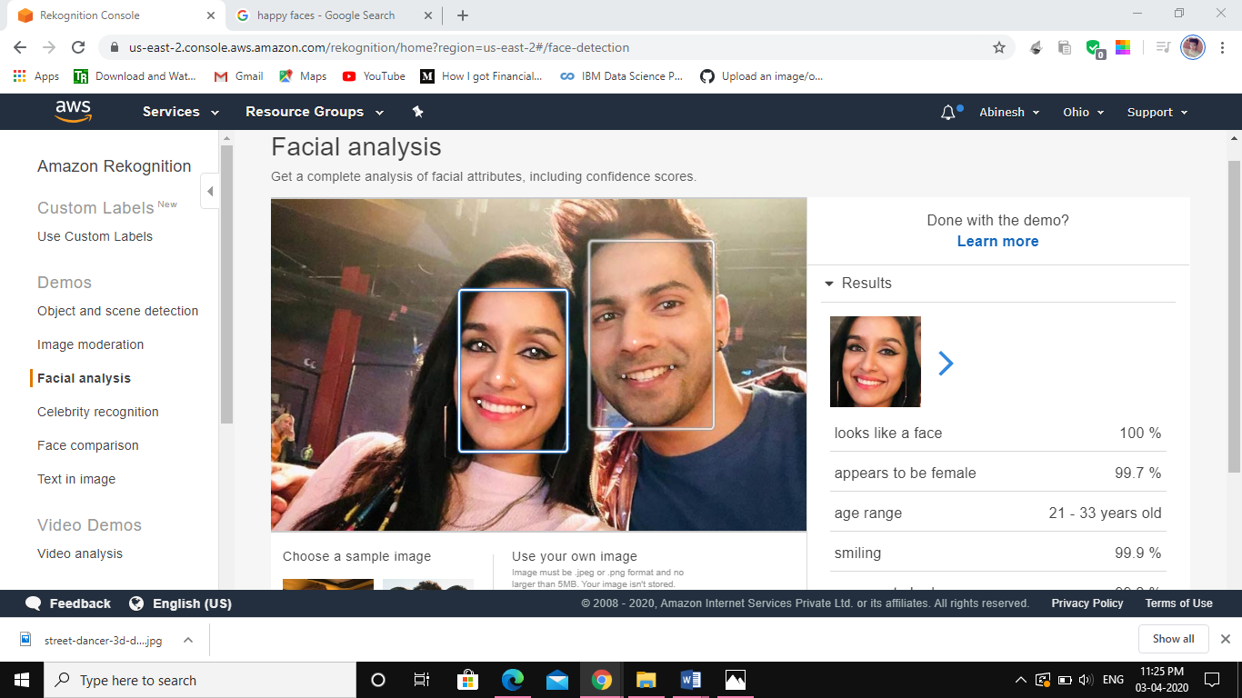

**2)Face Compare**

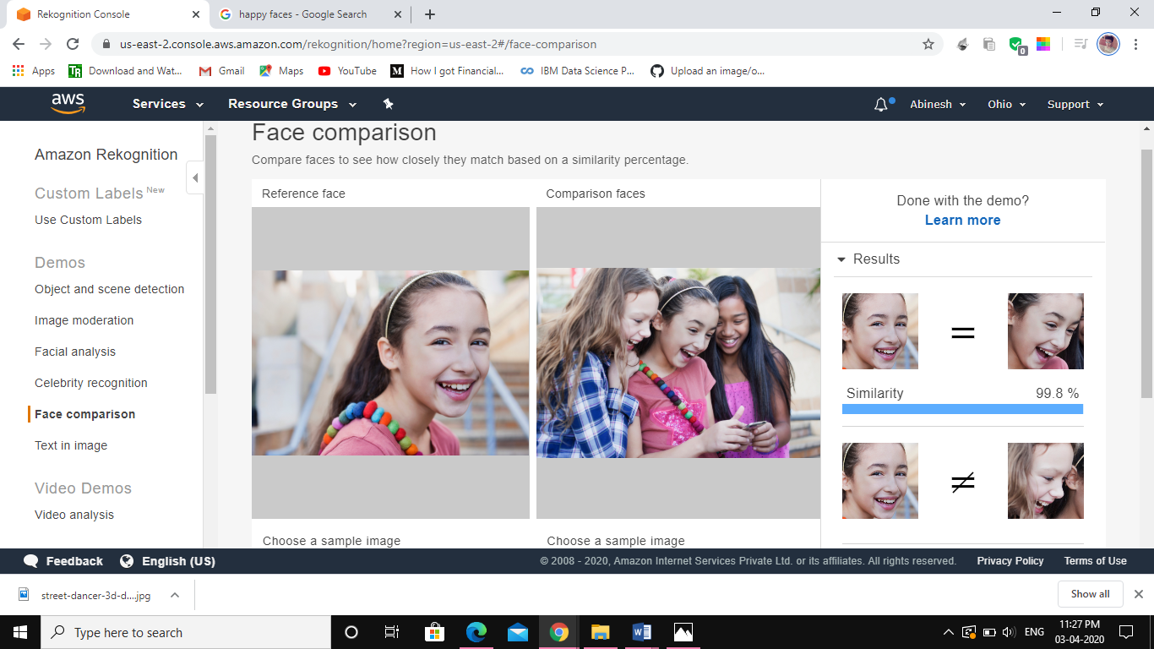

**3)Celebrity Recognition**

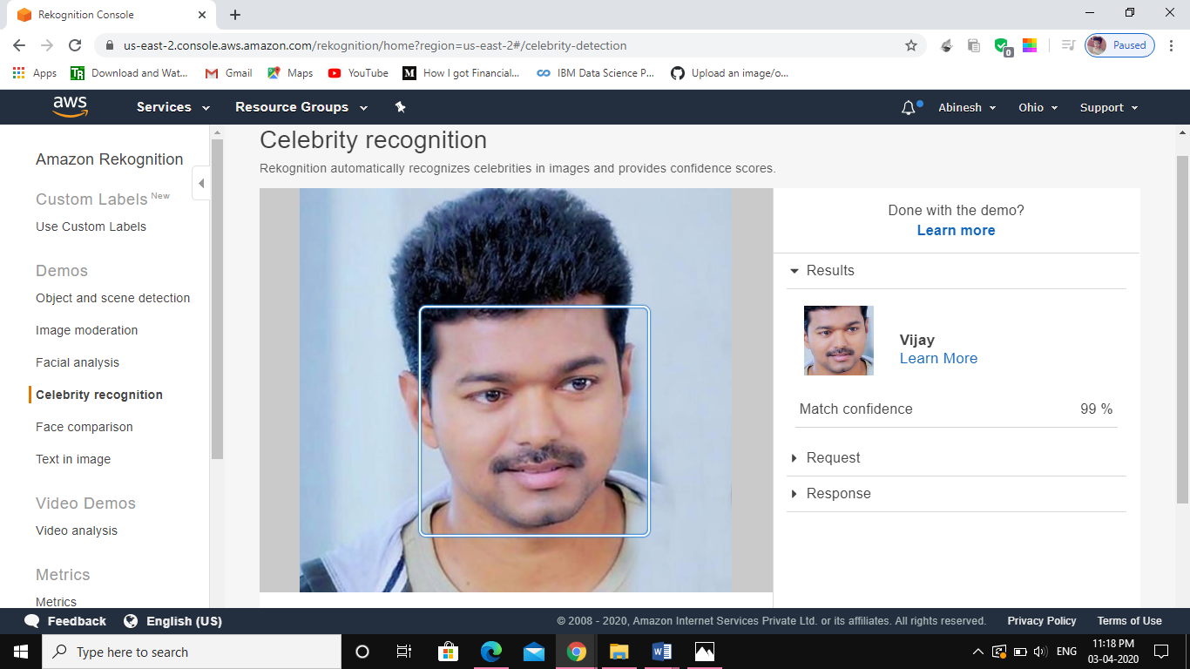

**4)Text in Image**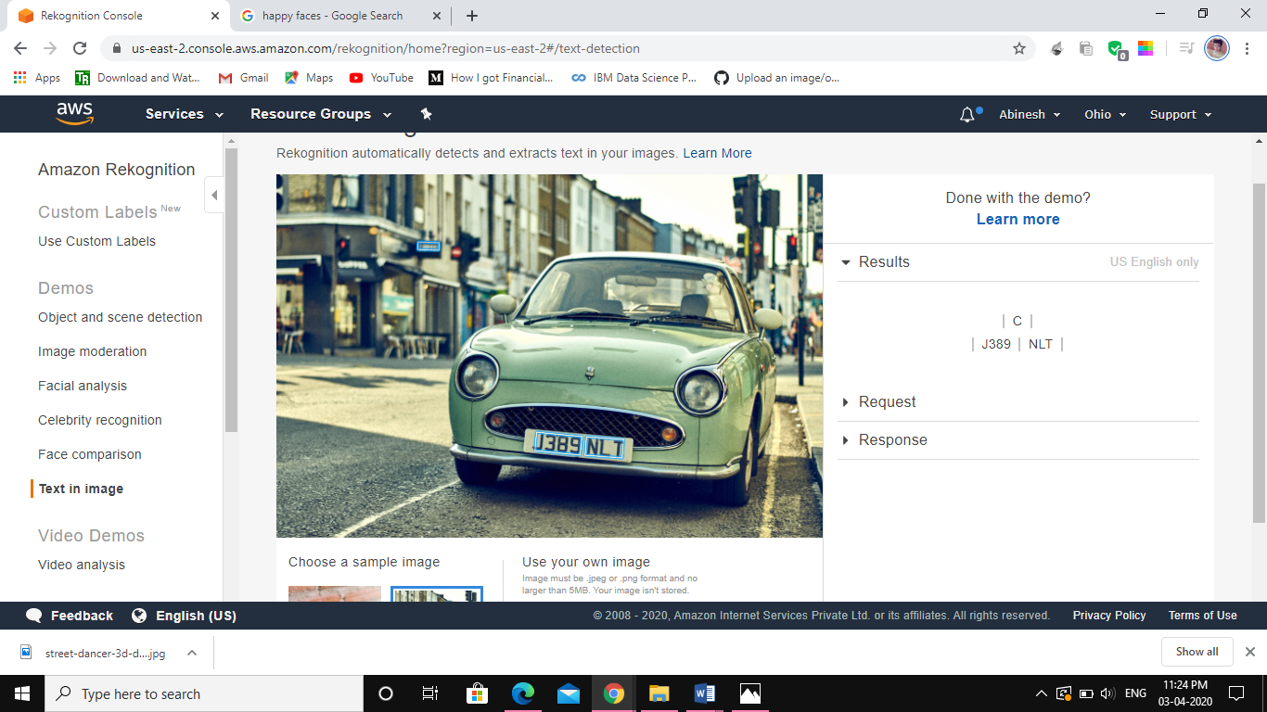

**Screenshots needed for EC2 & S3**

1. **Installing aws-sdk**

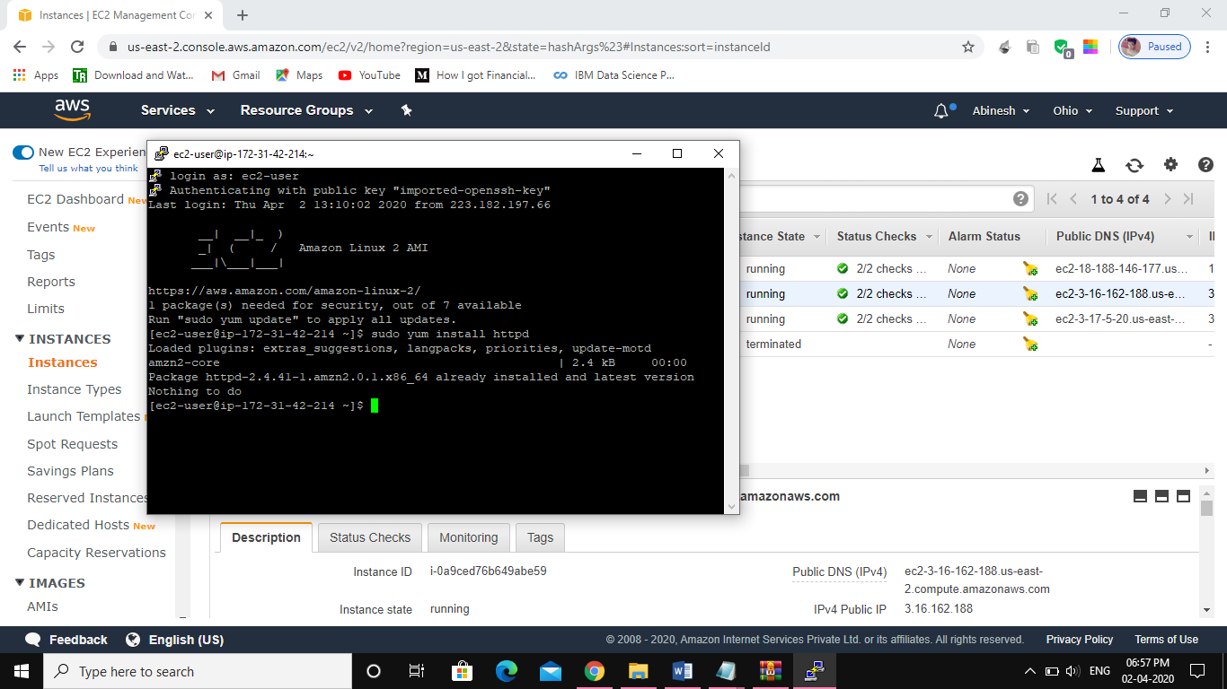

1. **Installing php**

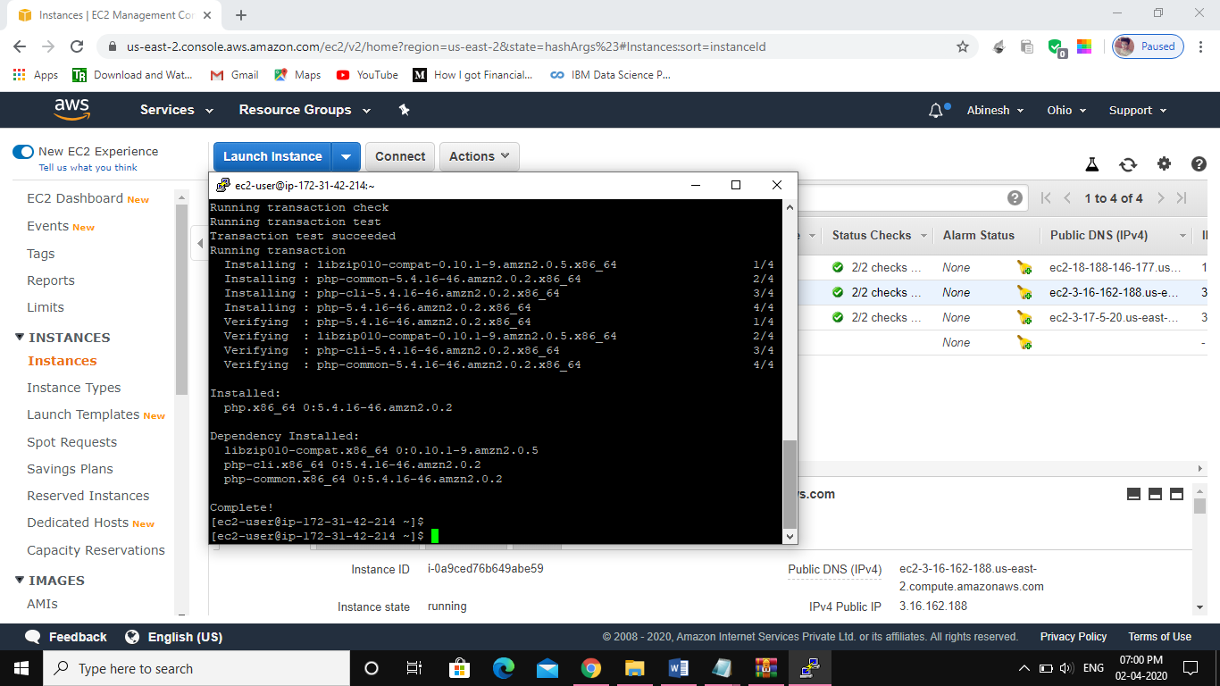

**3)index.php file code**

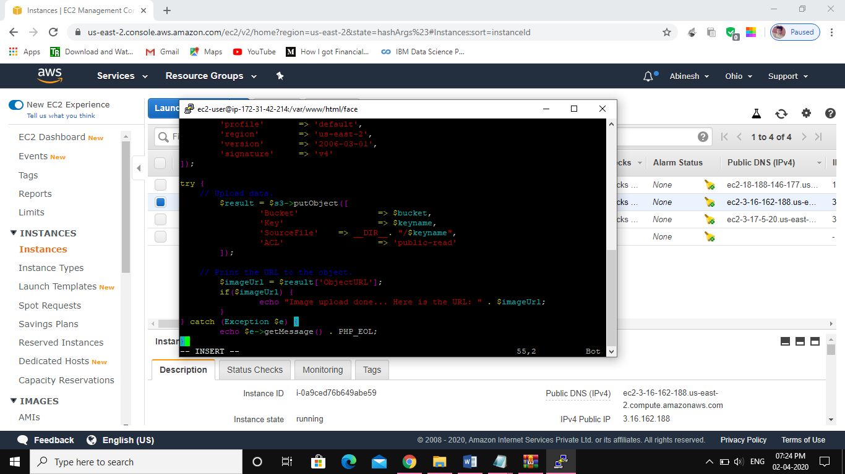**4) Upload success screenshot**

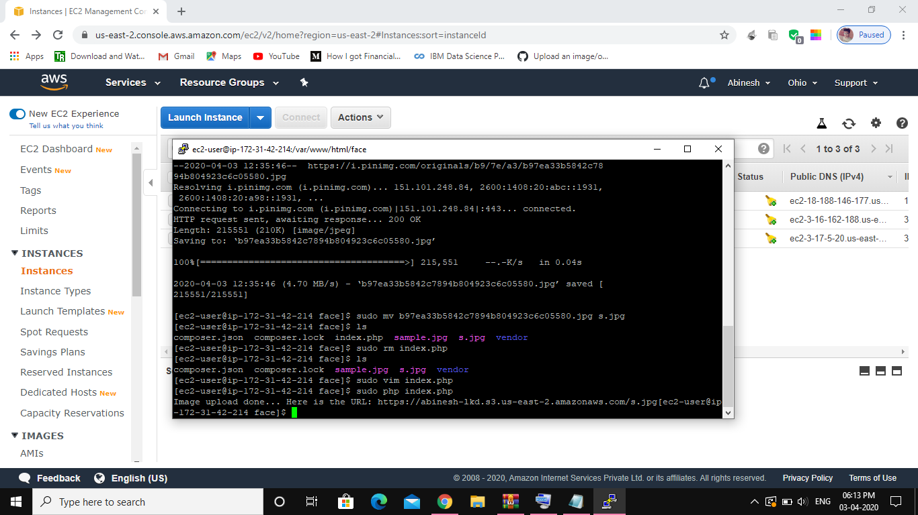

**Screenshots needed for EC2 & Rekognition**

1. **Face Detect success screenshot**

